Software Requirements Specification (SRS)

Table of Contents
- Introduction
1.1 Purpose
1.2 Document Conventions
1.3 Intended Audience and Reading Suggestions
1.4 Product Scope
1.5 References
- Overall Description
2.1 Product Perspective
2.2 Product Functions
2.3 User Classes and Characteristics
2.4 Operating Environment
2.5 Design and Implementation Constraints
2.6 User Documentation
2.7 Assumptions and Dependencies
- External Interface Requirements
3.1 User Interfaces
3.2 Hardware Interfaces
3.3 Software Interfaces
3.4 Communications Interfaces
- System Features
4.1 User Registration
4.2 User Login
4.3 Flight Booking
4.4 Baggage Management
4.5 Flight Management
4.6 Payment Processing
- Other Nonfunctional Requirements
5.1 Performance Requirements
5.2 Safety Requirements
5.3 Security Requirements
5.4 Software Quality Attributes
5.5 Business Rules
- Other Requirements
Appendix A: Glossary
Appendix B: Analysis Models
Appendix C: To Be Determined List

Airport Management System (AMS)
Version: 1.0
Prepared by: Aleem Abbas

Revision History
Name | Date | Reason | Version
Aleem Abbas | 5/3/2026 | Initial Draft | 1.0

1. Introduction

1.1 Purpose
This document specifies the requirements for the Airport Management System (AMS). It defines the expected behavior of the system and serves as a guideline for developers, testers, and stakeholders.

1.2 Document Conventions
- Headings are numbered for clarity
- Functional requirements are labeled as REQ-x
- Priority levels: High, Medium, Low

1.3 Intended Audience and Reading Suggestions
This document is intended for:
- Developers → for implementation
- Testers → for validation
- Project supervisors → for evaluation
Readers should begin with Section 1 and proceed sequentially.

1.4 Product Scope
The Airport Management System (AMS) is a web-based system designed to automate airport operations such as passenger management, flight booking, baggage handling, and payment processing. The system aims to improve efficiency, accuracy, and user experience.

1.5 References
- IEEE SRS Template
- Project SDS Document

2. Overall Description

2.1 Product Perspective
AMS is a standalone web-based application that interacts with external services such as payment gateways and regulatory databases.

2.2 Product Functions
Major system functions include:
- User registration and login
- Flight booking
- Flight scheduling
- Baggage handling
- Payment processing
- Admin management

2.3 User Classes and Characteristics

Administrator
- High-level access
- Manages flights, airlines, and system data

Passenger
- Basic user
- Books flights and makes payments

Airport Staff
- Operational role
- Handles baggage and logistics

2.4 Operating Environment
- Web browsers (Chrome, Edge)
- Database server
- Internet required

2.5 Design and Implementation Constraints
- Must integrate with payment gateway
- Requires secure data handling
- Dependent on internet connectivity

2.6 User Documentation
- User manual
- Online help guide

2.7 Assumptions and Dependencies
- Users understand basic web usage
- External APIs remain available

3. External Interface Requirements

3.1 User Interfaces
- Web dashboards for Admin and Users
- Forms for booking and registration

3.2 Hardware Interfaces
- Standard computing devices (PC, laptop)

3.3 Software Interfaces
- Payment Gateway
- Database system

3.4 Communications Interfaces
- Internet (HTTP/HTTPS protocols)

4. System Features

4.1 User Registration

4.1.1 Description and Priority
Allows users to create accounts (High Priority)

4.1.2 Stimulus/Response
User enters details → System validates → Account created

4.1.3 Functional Requirements
- REQ-1: System shall allow users to register
- REQ-2: System shall validate input data
- REQ-3: System shall store user data securely

4.2 User Login

Description and Priority
Allows users to access system (High)

Functional Requirements
- REQ-4: System shall authenticate users
- REQ-5: System shall deny invalid login attempts

4.3 Flight Booking

Description and Priority
Users can book flights (High)

Stimulus/Response
User selects flight → System checks availability → Booking confirmed

Functional Requirements
- REQ-6: System shall display available flights
- REQ-7: System shall allow booking
- REQ-8: System shall generate ticket

4.4 Baggage Management

Functional Requirements
- REQ-9: Staff shall log baggage weight
- REQ-10: System shall flag overweight baggage

4.5 Flight Management (Admin)

Functional Requirements
- REQ-11: Admin shall add flights
- REQ-12: Admin shall update flight schedules

4.6 Payment Processing

Functional Requirements
- REQ-13: System shall process payments
- REQ-14: System shall support multiple payment methods
- REQ-15: System shall validate transactions

5. Other Nonfunctional Requirements

5.1 Performance Requirements
- System should handle multiple concurrent users

5.2 Safety Requirements
- Prevent data loss

5.3 Security Requirements
- Secure login authentication
- Data encryption

5.4 Software Quality Attributes
- Reliability
- Scalability
- Usability

5.5 Business Rules
- Only Admin can manage flights
- Only registered users can book flights

6. Other Requirements
- Database consistency must be maintained

Appendix A: Glossary
- AMS: Airport Management System
- Admin: System controller

Appendix B: Analysis Models(USE –CASE DIAGRAM)

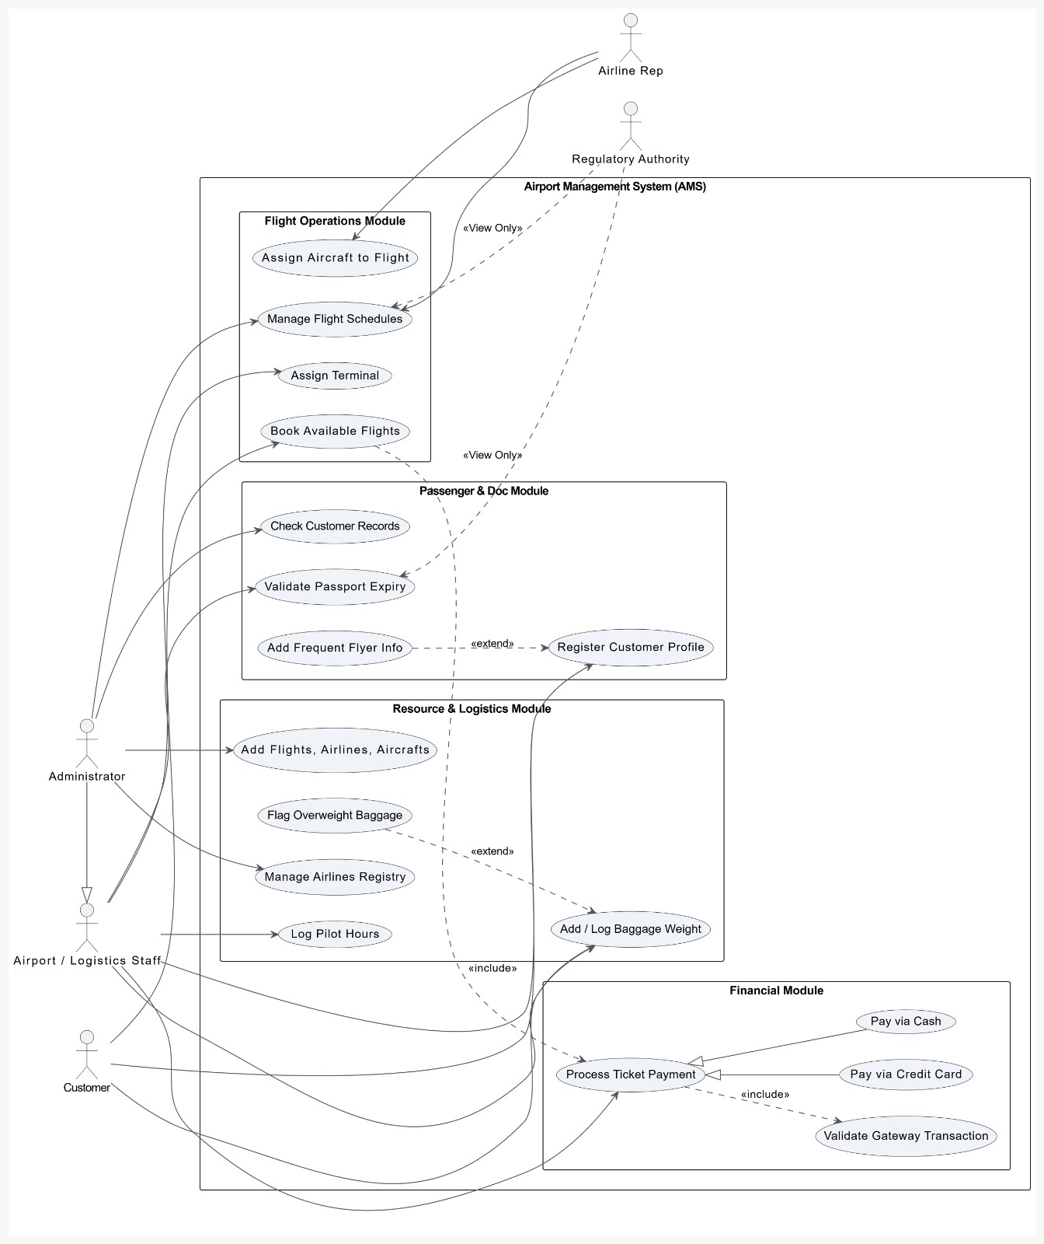

Appendix C: To Be Determined List
- Payment gateway details (TBD).

